Ex.No.11 STUDY OF SOCKET PROGAMMING IN PYTHON
Aim:
To study the concepts of socket programming in python.
STUDY OF SOCKET PROGAMMING IN PYTHON
A network socket is one endpoint of a two-way communication link between two programs
running on a network. It is a software-based handle combining an IP address and a port
number, allowing different processes to send and receive data across a device or the internet
Socket programming in python

Python&#39;s core networking library is Socket Module.
Python&#39;s socket module has both class-based and instances-based
methods.
Class-based method is an intuitive approach which doesn&#39;t need an
instance of a
socket object.
For example, in order to print a machine&#39;s IP address, you don&#39;t need a
socket
object. Instead, just call the socket&#39;s class-based methods.
In instance-based method, if some data needed to be sent to a server
application,
it is more intuitive to create a socket object to perform that explicit
operation.
This module has everything you need to build socket servers and clients.

Algorithm 1: TCP Server
Input: Client message
Output: Response message to the client
1. Start
2. Import the socket module.
3. Create a TCP socket using socket().
4. Bind the socket to the IP address localhost and port number 5000.
5. Put the server socket into listening mode using listen().
6. Wait for a client connection using accept().
7. Receive the message from the client using recv().
8. Decode the received message.

9. Display the client&#39;s message.
10. Create a response message.
11. Encode and send the response to the client using send().
12. Close the client connection.
13. Close the server socket.
14. Stop
TCP Client
Input: Message to be sent to the server
Output: Response received from the server
1. Start
2. Import the socket module.
3. Create a TCP socket using socket().
4. Connect to the server using connect() with localhost and port 5000.
5. Create a message to send to the server.
6. Encode the message.
7. Send the message to the server using send().
8. Wait for the server&#39;s response using recv().
9. Decode the received response.
10. Display the server&#39;s response.
11. Close the client socket.
12. Stop

PROGRAM(Server):
# TCP Server Program
import socket
# Create a socket
server_socket = socket.socket(socket.AF_INET, socket.SOCK_STREAM)
# Bind IP address and port
server_socket.bind((&quot;localhost&quot;, 5000))
# Listen for client connection
server_socket.listen(1)
print(&quot;Server is waiting for connection...&quot;)
# Accept client connection
conn, address = server_socket.accept()
print(&quot;Client connected:&quot;, address)
# Receive message from client
message = conn.recv(1024).decode()
print(&quot;Message from client:&quot;, message)
# Send response to client
response = &quot;Hello Client! Message received successfully.&quot;
conn.send(response.encode())
# Close connection
conn.close()
server_socket.close()

PROGRAM (CLIENT):
# TCP Client Program
import socket
# Create a socket
client_socket = socket.socket(socket.AF_INET, socket.SOCK_STREAM)
# Connect to server
client_socket.connect((&quot;localhost&quot;, 5000))
# Send message to server
message = &quot;Hello Server!&quot;
client_socket.send(message.encode())
# Receive response from server
response = client_socket.recv(1024).decode()
print(&quot;Message from server:&quot;, response)
# Close connection
client_socket.close()

SAMPLE OUTPUT:
Server Output
C:\Python&gt; python server.py
Server is waiting for connection...
Client connected: (&#39;127.0.0.1&#39;, 54321)
Message from client: Hello Server!
Client Output
C:\Python&gt; python client.py
Message from server: Hello Client! Message received successfully.

OUTPUT:
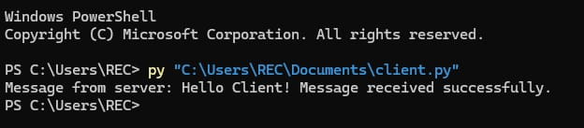

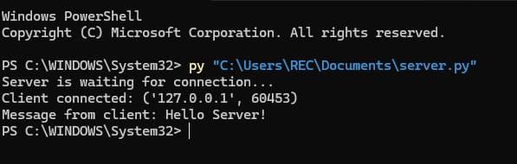

RESULT:
Thus socket programming in python is studied.

